Contents

1. About Performance Engineering 3

1.1 About Phase1: 3

1.2 About Phase2: 4

1.3 The Microsoft Teams for Performance Engineering Summary 5

Contact person in my absence 5

What is next? 6

2. About Masking 7

2.1. Current Status as on 21-Jan-2022: 7

Contact Person in my absence: 7

What is next? 7

1. About Oracle Goldengate 9

Contact Person in my absence: 9

What is next? 9

2. About Single Sign On 10

4.1 How to use CAS/SPNEGO/AD 10

The email communication for getting key.tab to Zurich from Kaneko-san 11

Document from Long 11

4.2 AD Consolidation 12

4.2.1 About required Changes in IG: 12

4.2.2. About Polisy/J 12

Contact person in my absence: 12

What is next? 13

3. About Log4j Vulnerability 14

6. Technical Info 14

6.1 How to analyze issues of Oracle? 14

6.2: How to analyze issues of ORA-00060? 14

6.3: Which IGBatch thread is using which connection or session id of Oracle? 15

7. About NFR 15

7.1. NFR documents. 15

7.2 . The overall architecture 15

7.3. The environment usage layout 15

7.3.1. IG Runtime 16

7.3.2. Overall Zurich systems 16

7.3.3. Configure Failover WAS Profiles for High Availability 16

# About Performance Engineering

## 1.1 About Phase1:

The performance engineering has history as it has started from Phase 1. Sometimes we may need to refer the Phase1 performance matrix:

[​xlsx icon PA Batch PerformanceV1.08_DXC_Target.xlsx](https://dxcportal.sharepoint.com/:x:/r/sites/ZIG-Tech/Shared%20Documents/Performance%20Testing/PA%20Batch%20PerformanceV1.08_DXC_Target.xlsx?d=w4a87557a9bd34ee682e8e02b4e17a0f9&csf=1&web=1&e=9yNnva)

Link of the same file:

https://dxcportal.sharepoint.com/:x:/r/sites/ZIG-Tech/Shared Documents/Performance Testing/PA Batch PerformanceV1.08_DXC_Target.xlsx?d=w4a87557a9bd34ee682e8e02b4e17a0f9&csf=1&web=1&e=9yNnva

Refer sheet as shown below and column N and O which is the performance data of Phase1(SHI).

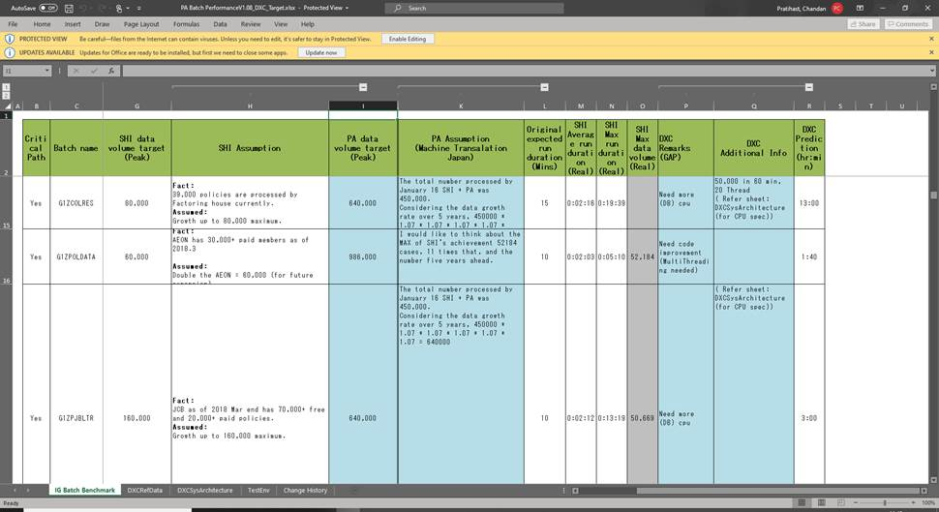

The actual evidence of Phase 1 is present in Zurich SharePoint, as that was done by Infosys. The link (Zurich SharePoint) for that is:

[https://ziapac.sharepoint.com/sites/ITServiceUnit/NewPAS/Shared%20Documents/Forms/AllItems.aspx?viewpath=%2Fsites%2FITServiceUnit%2FNewPAS%2FShared%20Documents%2FForms%2FAllItems%2Easpx&id=%2Fsites%2FITServiceUnit%2FNewPAS%2FShared%20Documents%2F40%2E%20Iteration%204%2F30%2E%20Infosys%2F08%2E%20Final%20PT%2FPerformance%20Test%20Reports%2FLot1%20PT%20Reports&viewid=154d9cf9%2Ded7e%2D46f7%2Dbc56%2D9420dd30ecd5](https://clicktime.symantec.com/3KGpzUDdbWbRGwXFRXW87Du7VN?u=https%3A%2F%2Fziapac.sharepoint.com%2Fsites%2FITServiceUnit%2FNewPAS%2FShared%2520Documents%2FForms%2FAllItems.aspx%3Fviewpath%3D%252Fsites%252FITServiceUnit%252FNewPAS%252FShared%2520Documents%252FForms%252FAllItems%252Easpx%26id%3D%252Fsites%252FITServiceUnit%252FNewPAS%252FShared%2520Documents%252F40%252E%2520Iteration%25204%252F30%252E%2520Infosys%252F08%252E%2520Final%2520PT%252FPerformance%2520Test%2520Reports%252FLot1%2520PT%2520Reports%26viewid%3D154d9cf9%252Ded7e%252D46f7%252Dbc56%252D9420dd30ecd5)

It was done in Lot1 and Lot2 and both those reports are present over there.

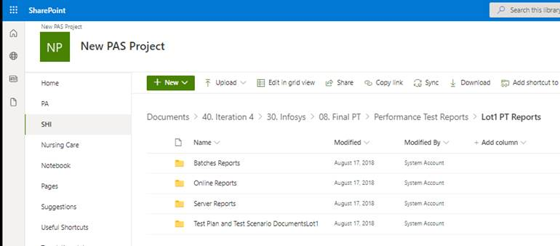

## 1.2 About Phase2:

Now the current reports I have saved in DXC Teams also; but these files are also managed by BAU DXC team for Phase 2:

[​Folder icon ZurichSidePerformaceReports](https://dxcportal.sharepoint.com/:f:/r/sites/ZIG-Tech/Shared%20Documents/Performance%20Testing/ZurichSidePerformaceReports?csf=1&web=1&e=ICtEt9)

Link of same file:

https://dxcportal.sharepoint.com/:f:/r/sites/ZIG-Tech/Shared Documents/Performance Testing/ZurichSidePerformaceReports?csf=1&web=1&e=ICtEt9

Here we have FCT performance report and improvement done on Oct 30.

Then BAU reports of phase2 batch performance till 11Jan, Since 19Dec.

## 1.3 The Microsoft Teams for Performance Engineering Summary

I had created MS Teams where in the wiki section we have some ideas and learning. Then in the files we have respective files. I have made some of the members as owner.

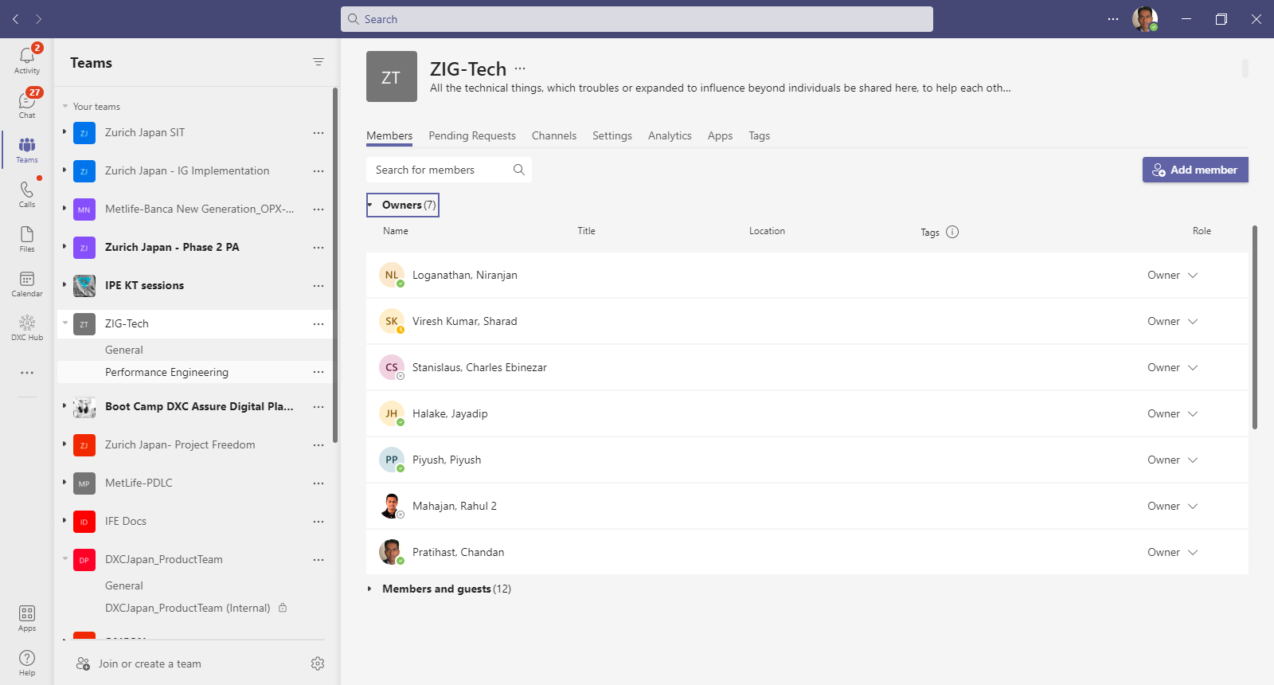

## Contact person in my absence

Brajesh/Niranjan/Jaydip(DB queries etc)/Piyush (IG solution improvement).

Brajesh and Niranjan have worked in Phase 1 in performance engineering. In Phase 2, later Brajesh also worked during FCT. Piyush/Jayadip and myself have restructured batch processing design in phase 2.

## What is next?

Though the PT and later FCT has shown that performance is as expected there are certain things, we must remain watchful. Those pointers are present at the team link:

[What is next? in Wiki](https://teams.microsoft.com/l/entity/com.microsoft.teamspace.tab.wiki/tab::9e52366a-7d0c-49cb-b332-29093ac81a10?context=%7B%22subEntityId%22%3A%22%7B%5C%22pageId%5C%22%3A2%2C%5C%22sectionId%5C%22%3A9%2C%5C%22origin%5C%22%3A2%7D%22%2C%22channelId%22%3A%2219%3A13f8f0e5c6bf46f0b3ccdb405fa3be68%40thread.tacv2%22%7D&tenantId=93f33571-550f-43cf-b09f-cd331338d086)

The points which I have highlighted here are, how to manage I/O waits, what to test to find more problematic queries and some new things like message queue.

Better to keep all these ideas in consideration as having lots of idea is a better way to be prepared.

# About Masking

There are scripts which are used to do the masking of sensitive columns of IG Core Tables. The document which explains the design of this masking and which can be referred to make any changes are also created in Dec 2021. The document and the scripts are present in the git repository. Git Path is:

<https://github.dxc.com/cpratihast/integral-CustomerZurichJpn/tree/product/Documentation/DataChange/Oracle/Production-Data-Masking-Scripts/ig/Phase2>

## Current Status as on 21-Jan-2022:

The script is currently ready on PRD22 AIX DB server of Zurich environment. The Camouflage another tool which Zurich uses to detect the masking is completed or not produce wrong results. For this Zurich will have to make a judgement. I have written an email about this. I have also proposed to write a new tool like Reiwa_Scan which Sharad/Gaurav have given estimate also, but Zurich does not seem to have taken any decision to develop it as they were thinking Camouflage will work, but it is not working!

About Reiwa_Scan, the source code and design I had shared to Sharad and Gaurav in below email:

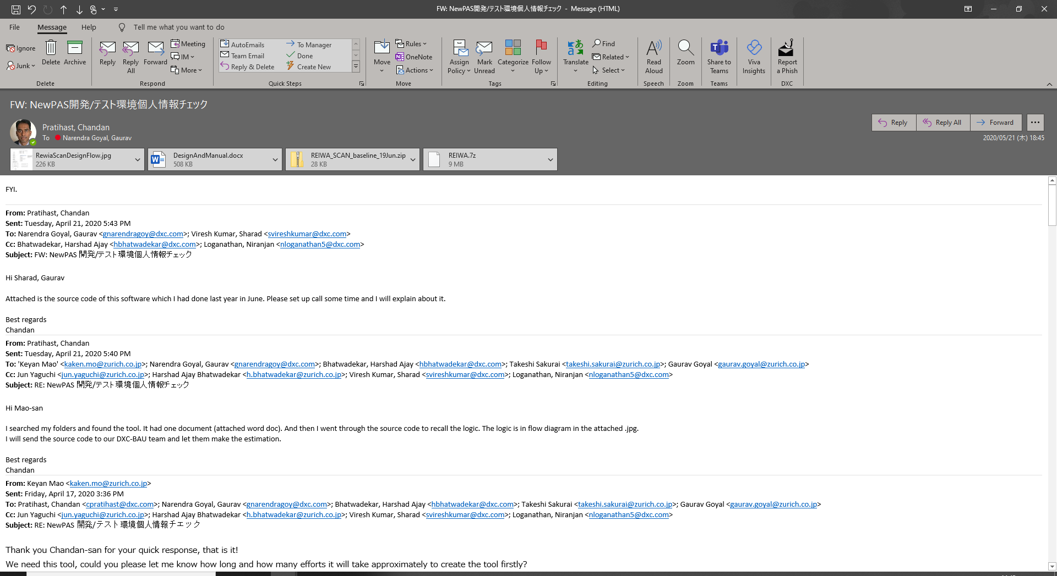

The email file which has that source code of Reiwa_Scan is present in git also: <https://github.dxc.com/cpratihast/IGProdSupport/tree/main/ReiwaScan>

Recently from first week of Feb, Zurich accepted that Masking is fine and it can be used. So no issue as of now.

## Contact Person in my absence:

The persons who have worked on this are: Charles, Jitendra. Day to day masking be done by Tuan. If any issue first Charles can see, if he cannot fix then Jitendra can help, if further help needed then Niranjan can help.

## What is next?

Not much but we can parallelize the tasks of export, masking and import to make it fast.

# About Oracle Goldengate

About Oracle Goldengate which is mainly done by Charles, I have kept the documents over here:

<https://github.dxc.com/cpratihast/OGG>

Here we have the troubleshooting steps also in the “issues” section.

The testing evidence of OGG is also present:

<https://github.dxc.com/cpratihast/OGG/tree/main/test>

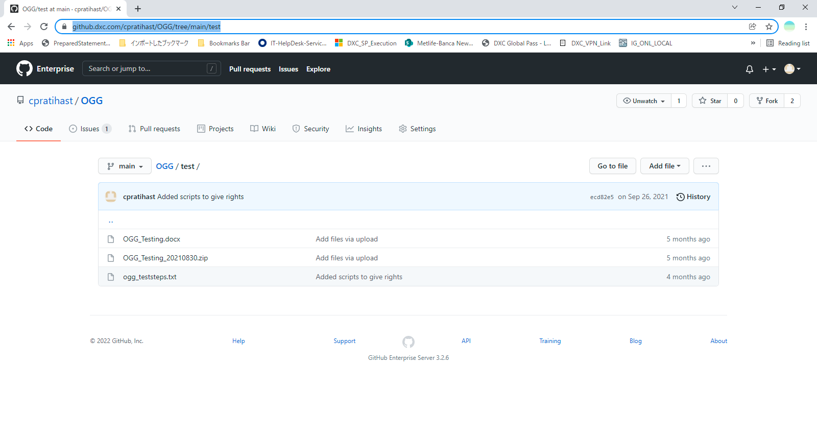

## Contact Person in my absence:

The persons who have worked on this is: Charles

## What is next?

For OGG, Zurich have not done one testing to check the sync-up and one issue was found, and we fixed it. Then we need to test it like real scenario. Which is not done because priority was for go live.

The email communication and PPT for Databackup/OGG is below:



Same file I have uploaded in Github also. [cpratihast](https://github.dxc.com/cpratihast)/[OGG](https://github.dxc.com/cpratihast/OGG)

# About Single Sign On

## 4.1 How to use CAS/SPNEGO/AD

In Zurich Japan, IG implemented SSO using CAS and backend is Active Directory (AD) and protocol is SPNEGO. The actual work was done by Kaneko-san and probably Vietnam team had supported it. I had once tried to dig-out to get more information on the mechanism involved in this work. That information I am sharing below.

Actually SSO following the CAS mechanism is very standard way and this information is present over internet: <https://apereo.github.io/cas/6.4.x/planning/Getting-Started.html>

This link has the architecture and details.

Referring the highlevel architecture diagram from the above link, IG works as CASified Client (CAS Client) and it follows CAS protocol to interact with the CAS.war (CAS Server). And the CAS.war authenticates with AD (in the case of production) using SPNEGO. In test environment CAS.war authenticates with LDAP.

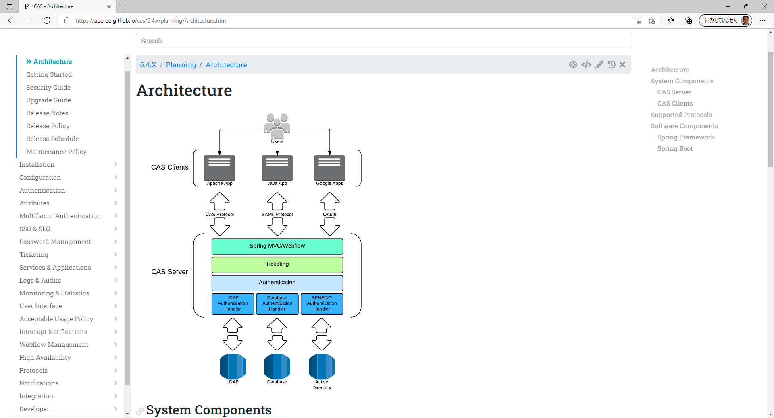Generally for implementing SSO, main interaction between DXC and Zurich happens for getting the key.tab file. Kaneko-san requests the key.tab from Zurich and once it is obtained the setting and changes are done by DXC (Kaneko-san till last year). Going forward we can connect with Vietnam team ([lnguyen58@dxc.com](mailto:lnguyen58@dxc.com)).

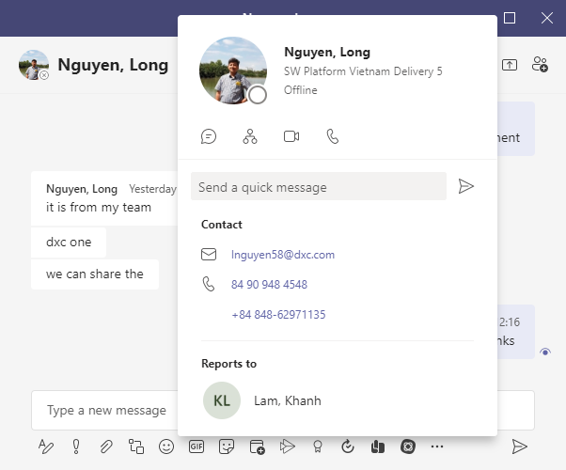

### The email communication for getting key.tab to Zurich from Kaneko-san

The email communication for getting the key.tab and then my understanding of the steps are saved at the following location:

<https://github.dxc.com/cpratihast/myktdoc/blob/main/SingleSignOn/FW%20Guiding%20Steps%20CASSPNEGOAD%20FW%20jpaigapp03%E7%94%A8%E3%81%AEkeytab%E3%83%95%E3%82%A1%E3%82%A4%E3%83%AB%E3%81%AE%E4%BD%9C%E6%88%90%E3%82%92%E3%81%8A%E9%A1%98%E3%81%84%E8%87%B4%E3%81%97%E3%81%BE%E3%81%99%E3%80%82.msg>

Please note in the above email top message is just my understanding (theoretical, I have not implemented this on my-own).

### Document from Long

Also, there is one document from Long as guideline for implementing CAS/SPNEGO/AD

This document from Long I have kept at git hub: https://github.dxc.com/cpratihast/myktdoc/tree/main/SingleSignOn

## 4.2 AD Consolidation

There is a global guideline in Zurich which Zurich Japan also has planned to implement is about the userid shall be 16 characters in Active Directory. To support this both Polisy/J and IG needs to make changes.

### 4.2.1 About required Changes in IG:

For IG changes I tried to find how can it be done and found that there is one project which has already done this. Then I have approached base team and then raised as JIRA.

In this JIRA information is about

1. What is the requirement from Zurich (in a ppt file)
2. Which project in DXC has already done this (a doc file)

The JIRA ticket is:

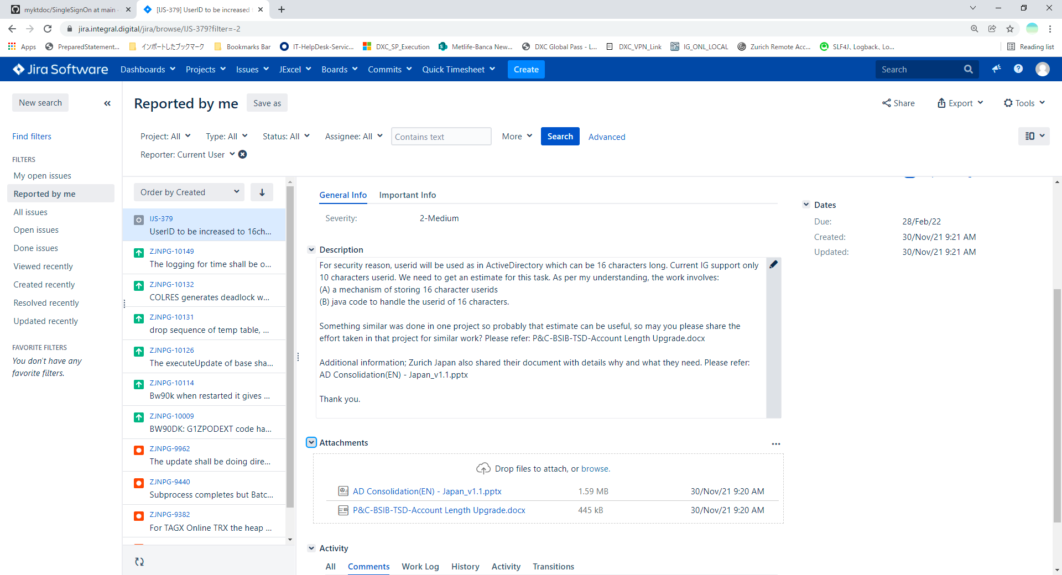

### 4.2.2. About Polisy/J

Please approach Suzuki-san/Abe-san. What I have heard in one meeting that it may take 4 to 6 months.

## Contact person in my absence:

Piyush/Niranjan. Vietnam team Long can support and from base team Rajiv can also be helpful.

## What is next?

1. Because GoLive was important this task is on hold.

2. We need to follow-up with base team to get the solution confirmed and the estimate. Basically JIRA IJ-379 be answered by base team. https://jira.integral.digital/jira/browse/IJS-379?filter=-2

3. Get the estimate for Polisy/J.

4. After 2 and 3 we should be responding to Zurich when they want to do AD consolidation. The last email is like below:

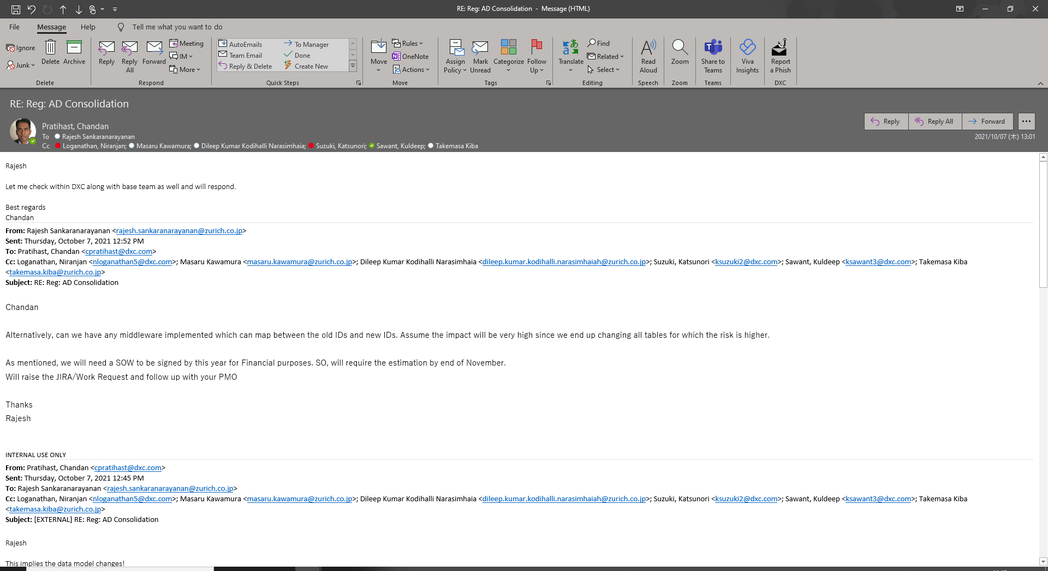

# About Log4j Vulnerability

For Zurich Japan project summary is: we are using total 5 different (war/ear) files, out of which **CAS5.war needs action** as presented in the excel file shared by Rhitwik, rest is fine.

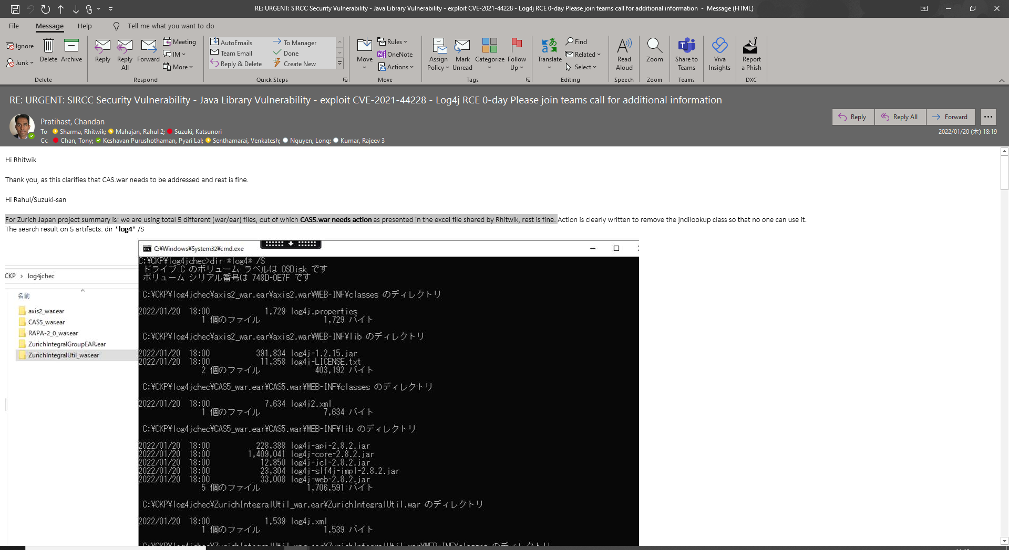 Please refer this email. Rahul can get it done.

# 6. Technical Info

## 6.1 How to analyze issues of Oracle?

Basically there are generic queries, and I have kept those in the master branch of the git repo, and it is accessible from Zurich environment also:

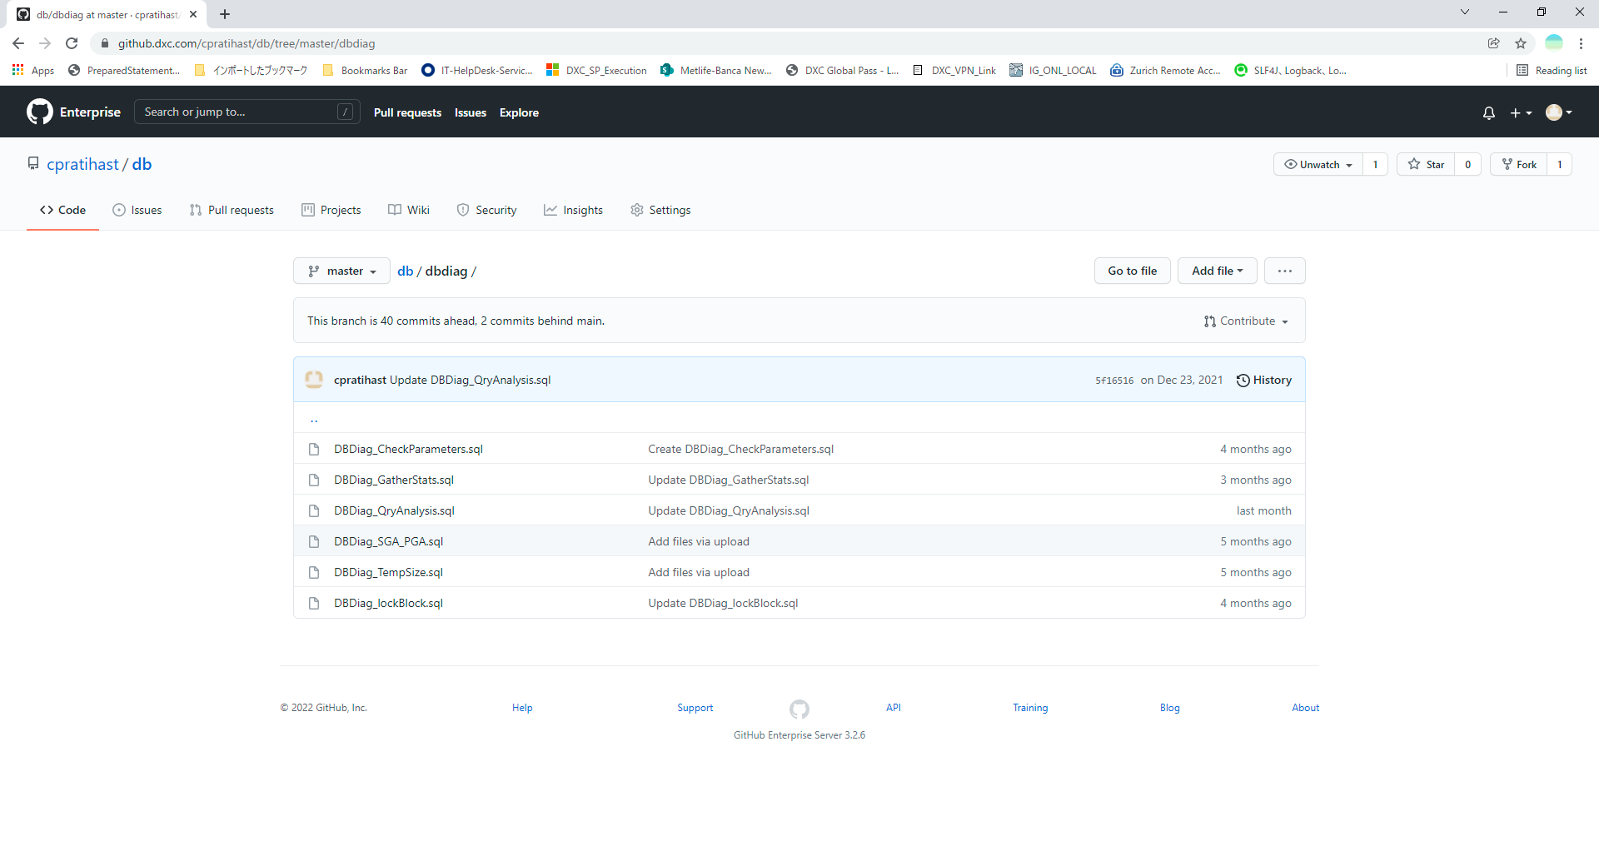

## 6.2: How to analyze issues of ORA-00060?

In many tickets I have explained about it. But, I have kept the PPT which explains why this deadlock occurs when we have initrans slot shortage, when concurrent writes are executed.

Please refer (**master** branch):

<https://github.dxc.com/cpratihast/db/tree/master/deadlockOra00060>

## **6.3: Which IGBatch thread is using which connection or session id of Oracle?**

Some times we get into the need to know which IGBatch thread is connected to which sessionid so we know which connection or transaction (if any) it is using. This is very rare need but if we need the idea is to do some small code change. In DAOImpl layers we have the connections, like returned objects from getConnection() or appVars.getConnection(). In that connection object just setClientInfo and that setting of the client info string will be visible in v$session. I have tried this and it works. There is one url for reference:

<https://franckpachot.medium.com/you-should-set-ocsid-clientid-e00cb81ed7e2>

# About NFR

## NFR documents.

In Zurich Japan, basic NFR documents are same as in SHI. But performance matrix are updated as per the PA data load. So, the NFR design document was same in SHI.

The NFR documents are present at:

<https://dxcportal.sharepoint.com/sites/zurichGIJapanNewPAS/Shared%20Documents/Forms/AllItems.aspx?newTargetListUrl=%2Fsites%2FzurichGIJapanNewPAS%2FShared%20Documents&viewpath=%2Fsites%2FzurichGIJapanNewPAS%2FShared%20Documents%2FForms%2FAllItems%2Easpx&id=%2Fsites%2FzurichGIJapanNewPAS%2FShared%20Documents%2F500%5FExecution%2F014%5FNFR&viewid=c3e11101%2D70aa%2D4ad5%2Da53c%2Ddfcadf7969e1>

## 7.2 . The overall architecture

The overall architecture of using load balancer and network layers are presented in the below PPT of DXC SharePoint. This is same as coming from SHI (originally created by Jun Xu). The last slide I have added to present that we are using only single server and is actual scenario in production.

In future we need to build on in to make high available architecture.

<https://dxcportal.sharepoint.com/:p:/r/sites/zurichGIJapanNewPAS/Shared%20Documents/500_Execution/014_NFR/Infra_PRD_v0.4.pptx?d=w0ec45191ff054dda9dd268760c787c0f&csf=1&web=1&e=ttPN5Z>

## 7.3. The environment usage layout

### 7.3.1. IG Runtime

In phase 1 when we had go-live immediately after than we have drawn a plan to name the environments and which environment will be used for testing, and which one for ready only.

This is the document to give idea about that. It is present in DXC SharePoint:

https://dxcportal.sharepoint.com/:p:/r/sites/zurichGIJapanNewPAS/Shared%20Documents/500_Execution/005_Environment_Management/Environment%20plan20181113_APM_2.PPTX?d=wfeebc57a67d4445fa80040e9318fc741&csf=1&web=1&e=fZpV3K

### 7.3.2. Overall Zurich systems

Below is the information where someone can understand all the systems and architecture, this was used to understand during SIT planning.

DXC SharePoint link: <https://dxcportal.sharepoint.com/:u:/r/sites/zurichGIJapanNewPAS/Shared%20Documents/500_Execution/014_NFR/ZurichOverallArchitecture.zip?csf=1&web=1&e=MndZgN>

### 7.3.3. Configure Failover WAS Profiles for High Availability

The steps are:

1. Assume we have one IBM HTTP Server (IHS) and one WAS Profile (PTXA) already working and let’s say the plugin configuration is plugin-cfg1.xml
2. Create new WAS profile (PTXB). No need to connect it to IHS. Check that http request going directly to profile is working fine.
3. Create plugin configuration for this WAS Profile. Use command GenPluginCfg.sh. Let us say this is plugin-cfg2.xml
4. Merge the two-plugin file using pluginCfgMerge.sh. Manually just add BackupServer tag pointing to WAS profile created in (B).
5. Copy this merged plug config in plugins folder of the webserver where we had plugin-cfg1.xml in step (A).

Then the failover starts working. Means when the PTXA is down the webserver automatically sends the request to PTXB.

Current Status: Tuan to experiment over it.

